**Pizza Sale SQL Queries**

## **KPI’s**

1. **Total Revenue:-**

select SUM(total_price) as Total_Sales from pizza_sales;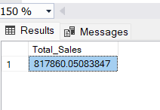

1. **Average order value:-**

select SUM(total_price) / COUNT(distinct(order_id)) as Average_order_value from pizza_sales;

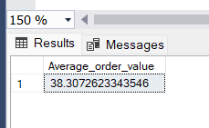

1. **Total pizzas sold:-**

select sum(quantity) as Total_Pizzas_Sold from pizza_sales;

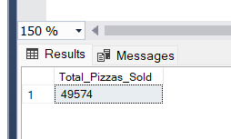

1. **Total Orders:-**

select COUNT(distinct order_id) as Total_Orders from pizza_sales;

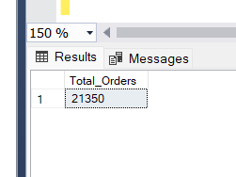

1. **Average Pizza Per Order:-**

select cast(cast(sum(quantity) as decimal(10, 2)) /

cast(count(distinct order_id) as decimal(10,2)) as decimal(10, 2)) as Avg_Pizza_Per_order

from pizza_sales;

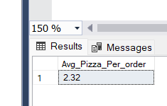

**B. Daily Trend for Total Orders**SELECT DATENAME(DW, order_date) AS order_day, COUNT(DISTINCT order_id) AS total_orders

FROM pizza_sales

GROUP BY DATENAME(DW, order_date)

***Output:***

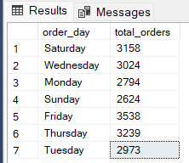

**C. Hourly Trend for Orders**

SELECT DATEPART(HOUR, order_time) as order_hours, COUNT(DISTINCT order_id) as total_orders

from pizza_sales

group by DATEPART(HOUR, order_time)

order by DATEPART(HOUR, order_time)

***Output***

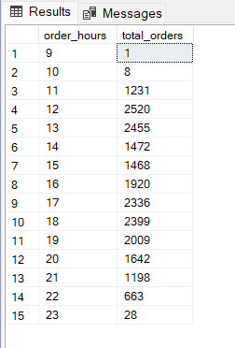

**D. % of Sales by Pizza Category**

SELECT pizza_category, CAST(SUM(total_price) AS DECIMAL(10,2)) as total_revenue,

CAST(SUM(total_price) * 100 / (SELECT SUM(total_price) from pizza_sales) AS DECIMAL(10,2)) AS PCT

FROM pizza_sales

GROUP BY pizza_category

***Output***

**D. % of Sales by Pizza Category**

SELECT pizza_category, CAST(SUM(total_price) AS DECIMAL(10,2)) as total_revenue,

CAST(SUM(total_price) * 100 / (SELECT SUM(total_price) from pizza_sales) AS DECIMAL(10,2)) AS PCT

FROM pizza_sales

GROUP BY pizza_category

***Output***

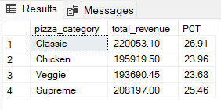

**E. % of Sales by Pizza Size**

SELECT pizza_size, CAST(SUM(total_price) AS DECIMAL(10,2)) as total_revenue,

CAST(SUM(total_price) * 100 / (SELECT SUM(total_price) from pizza_sales) AS DECIMAL(10,2)) AS PCT

FROM pizza_sales

GROUP BY pizza_size

ORDER BY pizza_size

***Output***

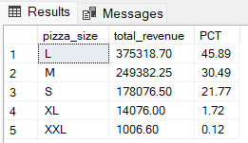

**F. Total Pizzas Sold by Pizza Category**

SELECT pizza_category, SUM(quantity) as Total_Quantity_Sold

FROM pizza_sales

WHERE MONTH(order_date) = 2

GROUP BY pizza_category

ORDER BY Total_Quantity_Sold DESC

***Output***

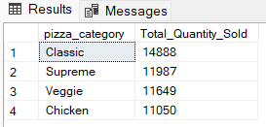

**G. Top 5 Best Sellers by Total Pizzas Sold**

SELECT Top 5 pizza_name, SUM(quantity) AS Total_Pizza_Sold

FROM pizza_sales

GROUP BY pizza_name

ORDER BY Total_Pizza_Sold DESC

***Output***

